Inputs:
- Netsuite FAM Additions Report (xls)
- Netsuite FAM Disposals Report (xls)
- FAM Monthly Depreciation (xml)
- Asset Summary Report (Month) (xml)
- Balance Sheet Balance for Fixed Assets and Amortization (xls)
- Monthly Trial Balance (xls)
- Prior month FA Rollforward (xlsx)

Process:
- Additions: In NS navigate to Fixed Assets > Searches > Asset Additions
- Asset Type: All
- Date:
- From To
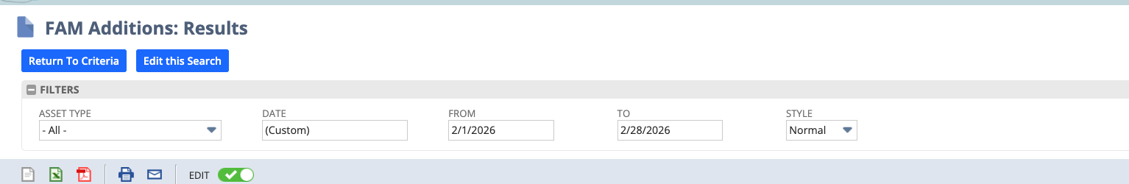
Add this data to the Additions tab

- Disposals: In NS navigate to Fixed Assets > Searches > Asset Disposals
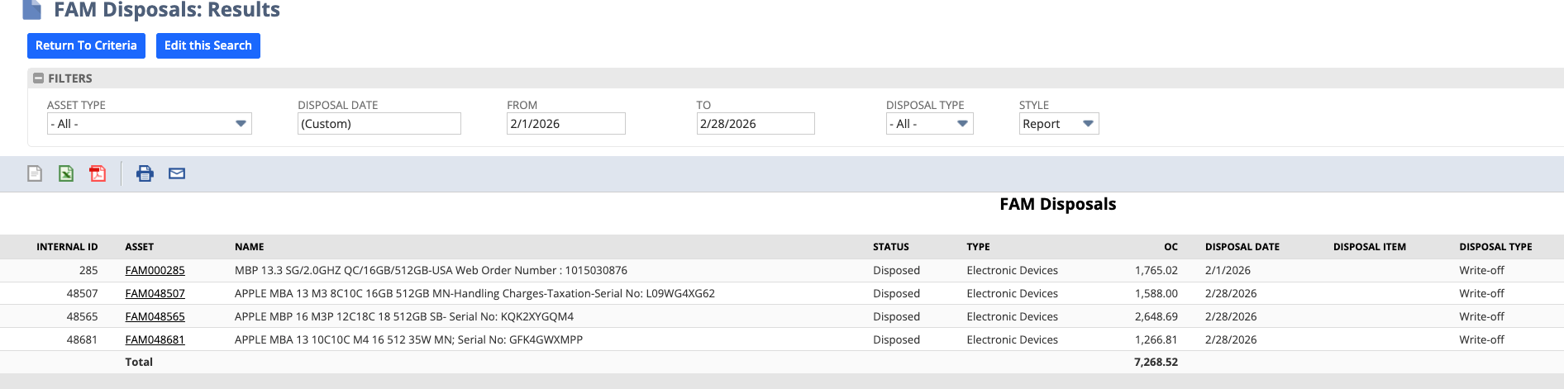
Add this data to the Disposals tab

- FAM Monthly Depreciation (FAM Monthly Depreciation 0226 tab)
In NS navigate to Fixed Assets > Reports> Generate Reports
Report Type: Depreciation Schedule Period Depreciation Report
Fill Out: Start Date and End Date
Run this for each Asset Type:
Electronic Devices, Furniture & Fixtures, Internally Developed Software, Lease Improvements
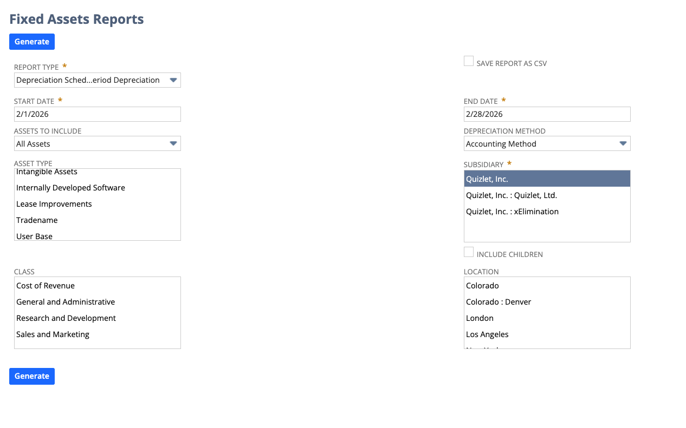
Add each report result underneath each other (See FAM Monthly Depreciation Tab 0126)

- Asset Summary Report:
In NS navigate to Fixed Assets > Reports> Generate Reports
Report Type: Asset Summary
Fill Out: Start Date and End Date
Run this for the following Asset Types:
Electronic Devices, Furniture & Fixtures, Internally Developed Software, Lease Improvements
Add the result to GL- FAM YYYY tab

- Balance Sheet Report
Add the balances for the closing month to tab GL- FAM YYYY tab
- Retain all the GL account line items as shown in the EO
  - 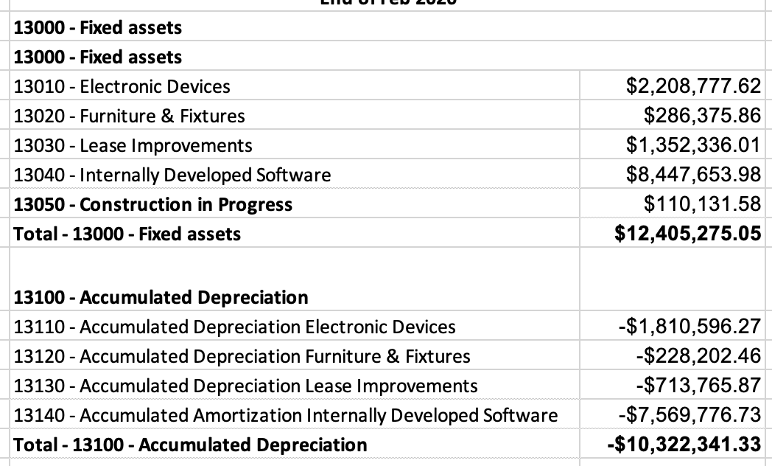
- Follow formulas in Column P and R
- Keep the FQ tags in Column Q

- Monthly Trial Balance
Run the Monthly Trial Balance Report for the closing month. Add the result to tab MonthlyTrialBalanceFY2026
- Retain the prior month’s data from the Prior month FA Rollforward input file

13000 - Fixed assets
13010 - Electronic Devices
13020 - Furniture & Fixtures
13030 - Lease Improvements
13040 - Internally Developed Software
13050 - Construction in Progress
13100 - Accumulated Depreciation
13110 - Accumulated Depreciation Electronic Devices
13120 - Accumulated Depreciation Furniture & Fixtures
13130 - Accumulated Depreciation Lease Improvements
13140 - Accumulated Amortization Internally Developed Software
- RFMonth to Month FY2026
  - Refer to the EO file to carry-over the formatting and cell references/formulas
  - Leverage the prior month’s FA Rollforward to populate prior months’ data (harcoded)

Output format:
RF Month to Month
Keep current process: For each month keep the formulas
Assets:
Total per Rollforward: Additions, Disposals, Ending Balance (Formulas are pulling from Additions, and Disposals tab)
Total per GL: Formulas are pulling from the Monthly Trial Balance FYMMMM
13100 - Accumulated Depreciation:
Total per Rollforward: Additions, Disposals, Ending Balance (Formulas are pulling from FAM Monthly Depreciation, and Monthly Trial Balance)

